Introduction
This study is investigating whether different areas in America have different average class sizes in middle school. Many places in America have different birth rates than other places and places with high birth rates are expected to have bigger average class sizes in middle school because the fraction of their residents who are kids is greater than the places with low birth rates. This fraction of residents who are kids explains typical larger average class sizes, because this results in more students in schools meaning more students in each class. Because different regions have different birth rates, this caused me to have an idea that different places will have different typical class sizes in middle school. Utah is believed to have the highest birth rate of any state in America, so I assume Utah has larger typical class sizes in middle school than most other states. This study is going to test whether these assumptions are true.
Methods
To get a good sample of typical class sizes in different regions, I passed out a survey that asked about geographical information such as where people were from, as well as how big their typical class sizes were in middle school. I had 105 responses before I copied them into a spreadsheet, which I will be using in the analysis. The survey included these questions:
- “If you grew up in Utah, which county?” [nominal]
- American Fork
- Beaver
- Box Elder
- Cache
- Carbon
- Daggett
- Davis
- Duchesne
- Eagle Mountain
- Emery
- Garfield
- Grand
- Herriman
- I did not grow up in the state of Utah
- Iron
- Juab
- Kane
- Layton
- Lindon
- Millard
- Morgan
- Ogden
- Orem
- Payson
- Piute
- Pleasant Grove
- Provo
- Rich
- Salt Lake
- San Juan
- Sanpete
- Saratoga Springs
- Sevier
- Springville
- Summit
- Tooele
- Uintah
- Wasatch
- Washington
- Wayne
- Weber
- “In middle school, how many students were in a typical class?” [ordinal]
- 1-5 students
- 6-10 students
- 11-15 students
- 16-20 students
- 21-25 students
- 26-30 students
- 31-35 students
- 36-40 students
- 41-45 students
- 46-50 students
- 51 or more students
Some experimental error that could have happened during my survey could have been failing to hand out questions to everyone I saw. This could have been avoided by simply asking everyone I saw to take it, which I could do in the future. Some experimental bias that could have happened during the survey could have been caused by me handing out my survey to people in only a few locations. This could have caused the results from that location to be similar to each other. This could be avoided in the future by making sure to ask the questions in many places.

Kruskal Wallis H Test
In my Kruskal Wallis H test, I grouped the responses in the question about counties/cities people grew up in into the group of A-B responses and the group of C-K responses including “I did not grow up in the state of Utah” and the group of L-Z responses.
H₀: there is no significant difference in average class sizes for the 3 groups listed above
H_{a}: there is a significant difference in average class sizes for the 3 groups listed above
SPSS Output:
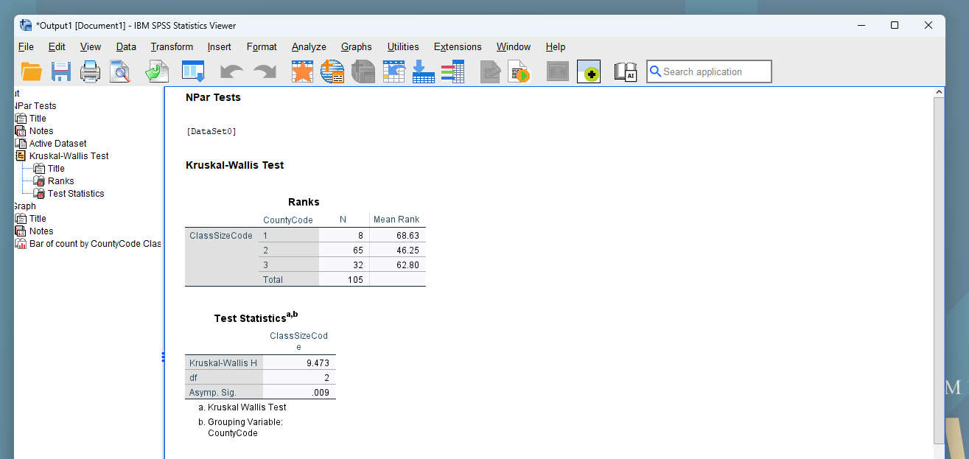

SPSS Graph:
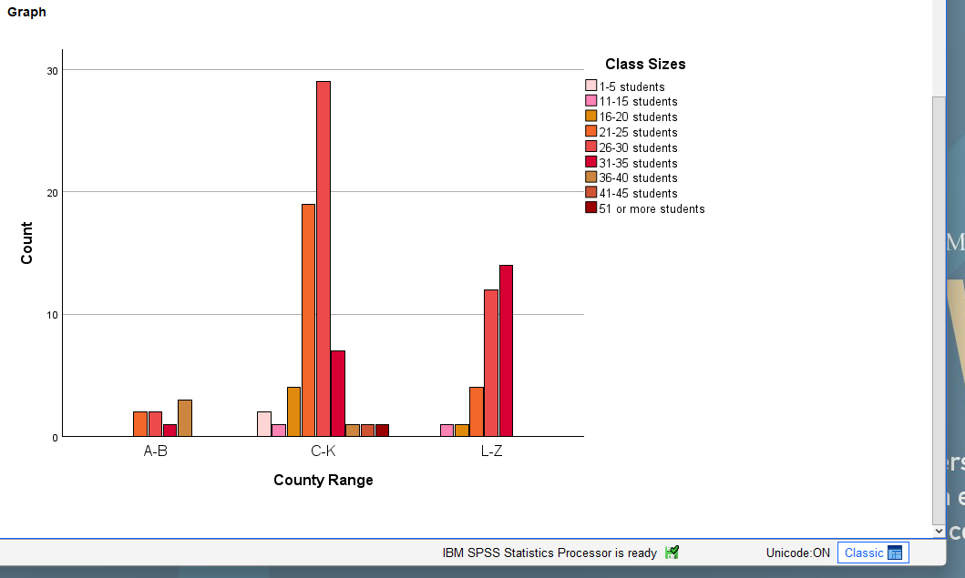
Here, I did a Kruskal Wallis H Test in SPSS of these hypotheses and the p value shown was 0.009. This low p value means we reject H₀ and accept H_{a}. In other words, there is a significant difference in the class sizes of these 3 groups of counties.

MannWhitney U Test
In my MannWhitney U test, I grouped the responses in the question about counties/cities people grew up in into the group that wasn’t from Utah, meaning the response “I did not grow up in the state of Utah” and into the group that was from Utah, meaning all other responses.
H₀: there is no significant difference between typical middle school class sizes of people who grew up in Utah and who didn’t
H_{a}: there is a significant difference between typical middle school class sizes of people who grew up in Utah and who didn’t
SPSS Output:
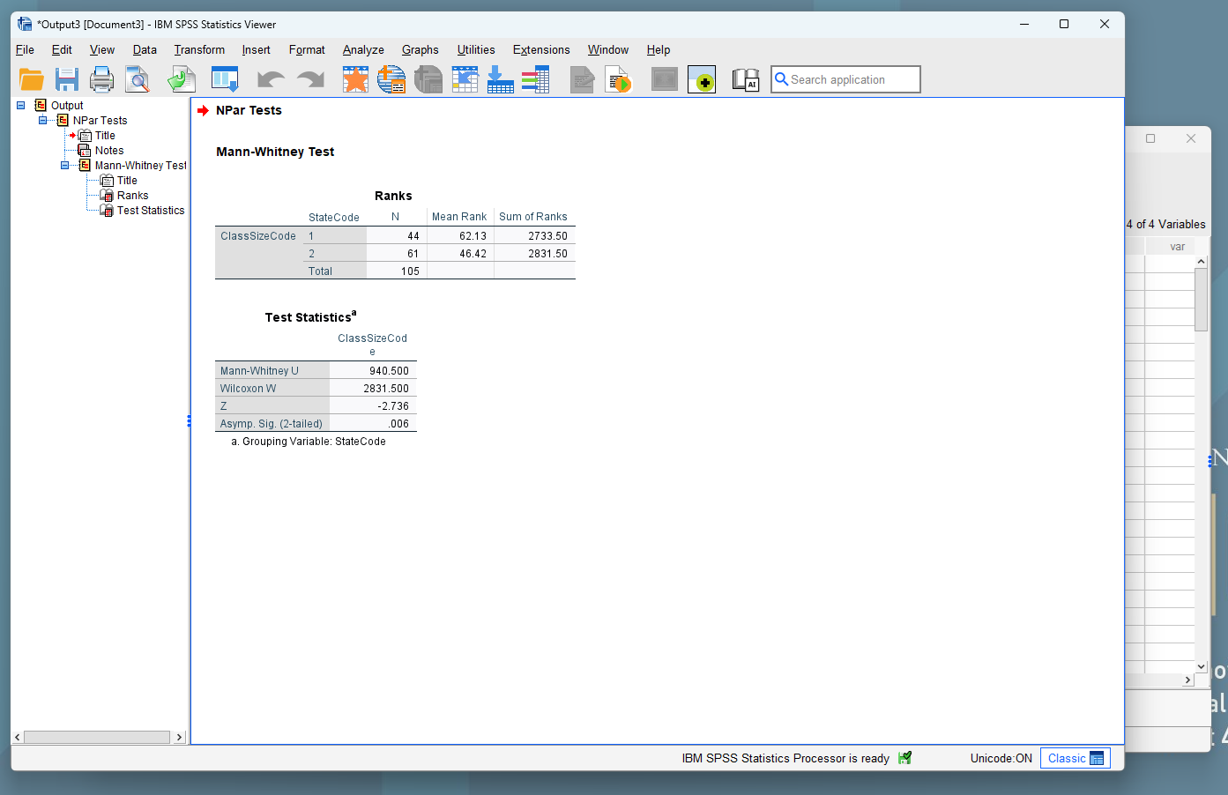

SPSS Graph:
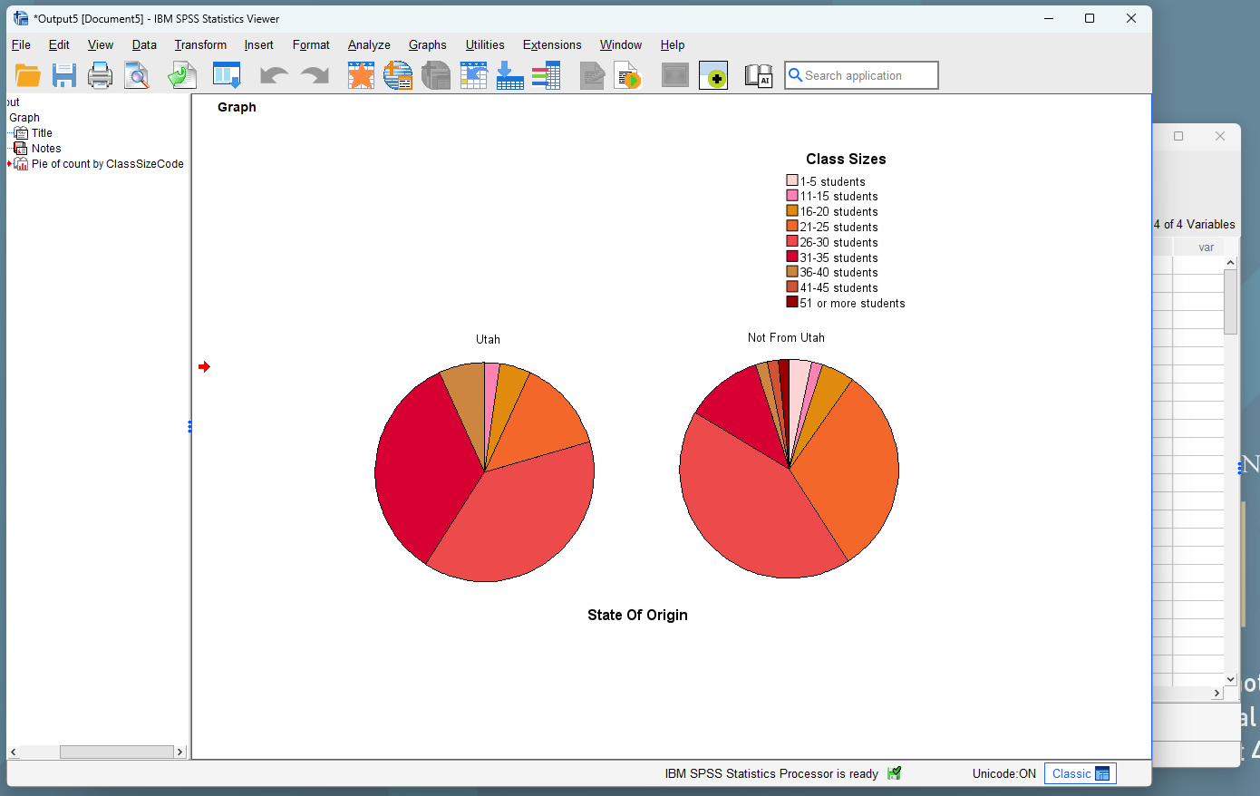
Here, when I ran the test in SPSS, it gave a p value of 0.006, which is significant, so we reject H₀ and accept H_{a}. The Z score was -2.736, when “From Utah” was the first label and “Not From Utah” was second, which specifically means the average middle school class size outside of Utah was smaller than inside Utah. The fact that Utah had bigger average class sizes is exactly what is expected, since Utah and places with higher birth rates have bigger classes, due to having a higher fraction of their population being children. There could have been some experimental bias given that I mostly asked people in the Orem and Provo area my questions when I asked people, given that this area is expected to have a higher average class size than other places in Utah, but my result was pretty significant, and even without this bias it would likely remain significant.
Chi Square Test
In my Chi Square test, I grouped the people into regions as shown below, where within Utah County I’m using “North East Utah County,” and “South East Utah County,” and “Western Utah County” and outside of Utah County but still in Utah, I’m using “Eastern Utah,” “Midwest Utah,” and “Western Utah” and outside of Utah but in America, I’m using “North,” “South,” “East,” and “West.” Anyone from outside of America will be labeled “Not From America.” These will be my 11 regions.
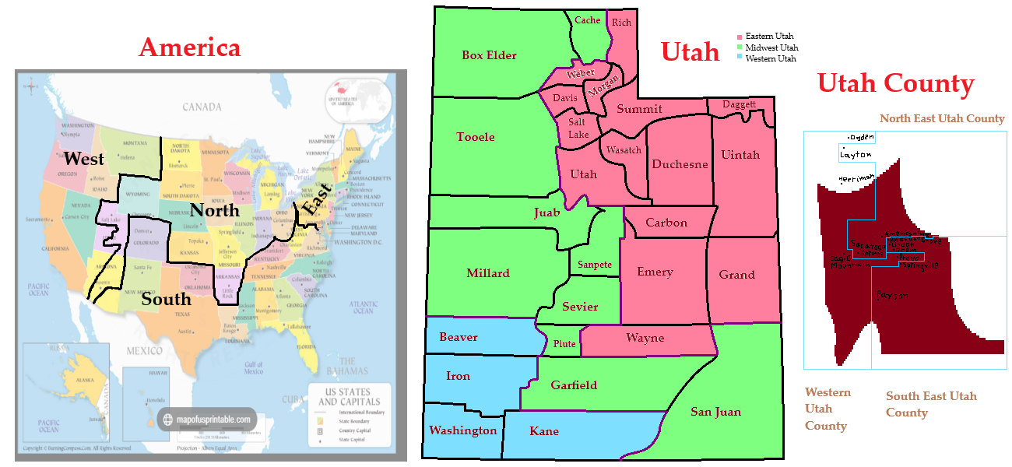
H₀: There is no significant difference in average middle school class sizes in the 11 regions I’ve defined above
H_{a}: There is a significant difference in average middle school class sizes in the 11 regions I’ve defined above

SPSS Output:
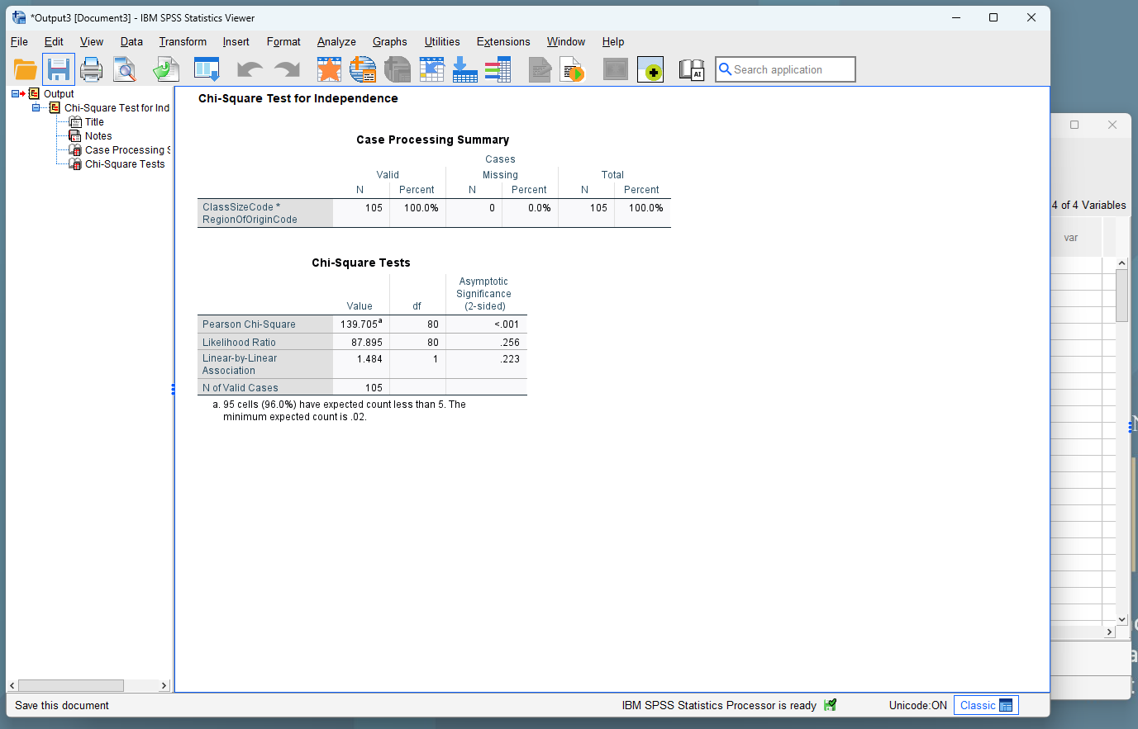

SPSS Graph:
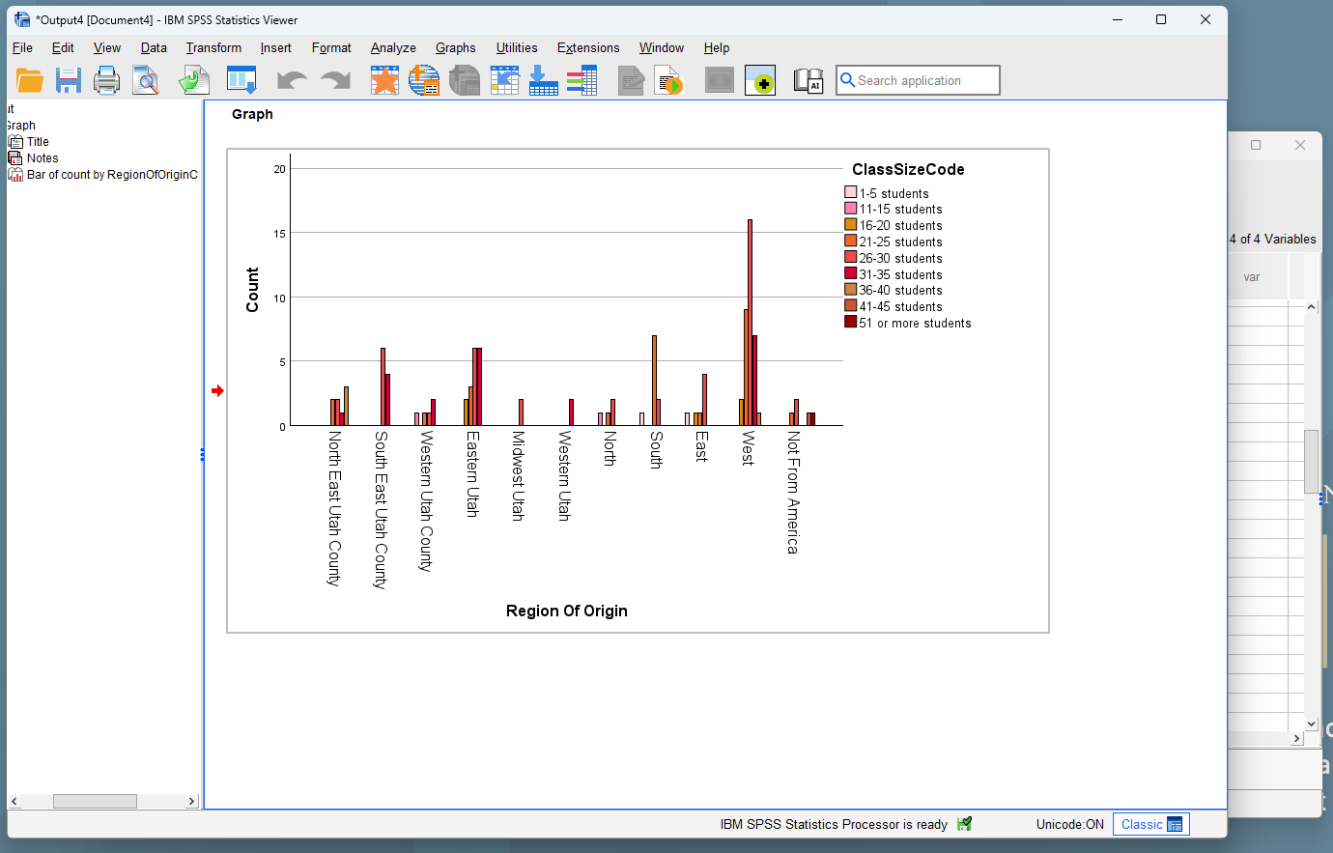
Here, when I ran the test in SPSS, I received a p value of <0.001. This is extremely significant. This means that I reject H₀ and accept H_{a}, meaning that there is a significant difference in the class sizes of different regions. This is what would be expected, since different places have different birth rates and different concentrations of teachers, both of which influence class sizes in middle school. However my test may have had weaker reliability than the others given that 95 out of the 99 cells had a count less than 5. However, the results were very significant, and so whether the increase in counts increases or decreases the significance, the test still remains significant.

